Date | 30/10/2025
Team Id | NM2025TMID03029
Project name | Optimizing User, Group and Role Management with Access Control and Workflows
Maximum mark | 2 marks

Customer Problem Statement Template:

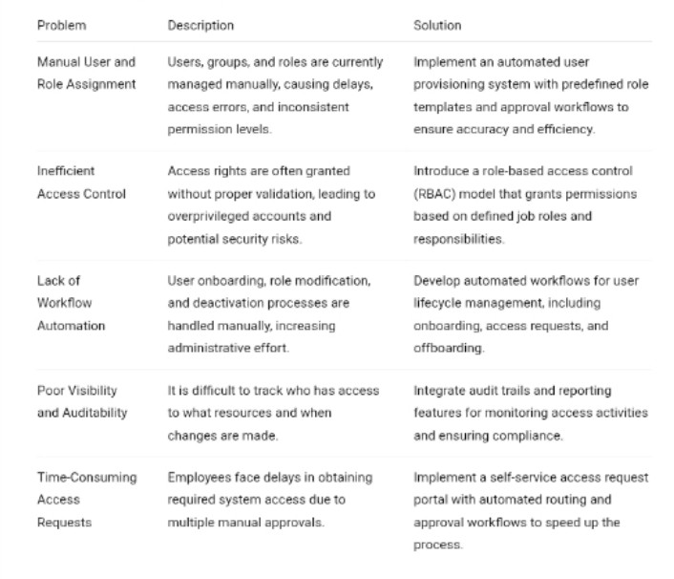

Organizations often struggle with inefficient user, group, and role management processes that rely heavily on manual operations, leading to security risks, access inconsistencies, and compliance challenges. The lack of centralized access control and automated workflows results in delays during user onboarding and offboarding, overprivileged accounts, and limited visibility into access changes. To address these issues, there is a need to optimize and automate user, group, and role management through a unified system that enforces role-based access control (RBAC), streamlines workflows, enhances security, and ensures compliance. This solution aims to improve operational efficiency, reduce human errors, and provide better governance over access permissions across the organization.

PROBLEM STATEMENT:

Problem | Description
  Solution
Manual User and Role Assignment | User accounts, groups, and roles are currently assigned manually, causing inconsistencies, errors, and delays in access provisioning. | Implement an automated user provisioning system with predefined role templates and approval workflows to ensure accurate and efficient access assignment.
Ineffective Access Control | Access permissions are often granted without proper validation, leading to overprivileged accounts and potential security risks. | Adopt a role-based access control (RBAC) framework that restricts permissions based on user roles and responsibilities.
Lack of Workflow Automation | User onboarding, modification, and offboarding processes are manually handled, increasing administrative workload. | Introduce automated workflows for user lifecycle events to streamline access requests, approvals, and revocations.
Limited Visibility and Auditing | Administrators face challenges tracking user activities and changes in access levels, making reporting difficult. | Integrate real-time audit trails and access reports to monitor user activity and ensure compliance with policies.
Slow Access Request Approvals | Manual approval chains delay access provisioning for new or transferred users. | Create a self-service access request portal with automated routing and notification workflows to speed up approvals.

